For Press Only

Registration for the 52nd JAIF Annual Conference

Please type or print in block letters and return this form
Email: media@jaif.or.jp by April 4, 2019

Title: □ Prof. □ Dr. □ Mr. □ Ms.
Name: __________________________________ / ___________________________________
(First Name) (Family Name)
Position: ____________________________________________________________________
Organization: ________________________________________________________________

Mailing Address: □ Office / □ Home
_________________________________________________________________________

Country: ____________________________________________________________________
Tel: _________________________________________________________________________
Fax: ________________________________________________________________________
E-mail: ______________________________________________________________________

JAIF will hold a Press Conference with Mr. M. Shellengberger, Founder and President of Environmental Progress from 11:45 to 12:15 on April 9 at the Tokyo International Forum (Room G510).
Please check below if you would like to attend the Press Conference.

Will Attend : □ Yes. □ No.

Press Secretariat:
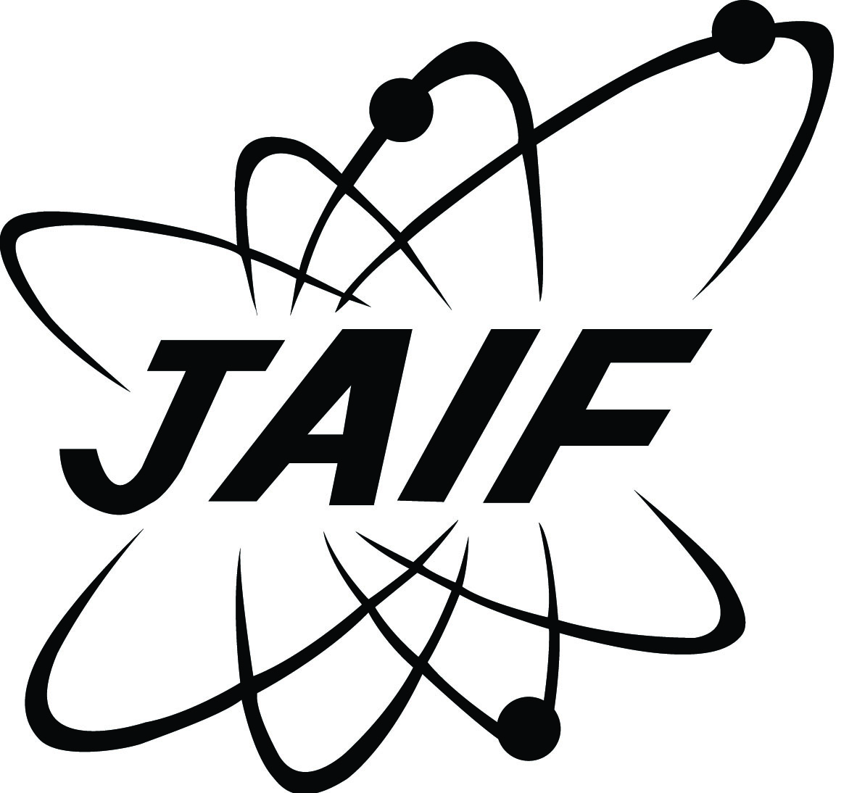
Kakuta (Mr.), Kimuro (Ms.)
Japan Atomic Industrial Forum, Inc. (JAIF)
11-19, Nibancho, Chiyoda-ku, Tokyo 102-0084, JAPAN
Tel: +81-3-6256-9312
E-mail: media@jaif.or.jp
HP: https://www.jaif.or.jp/en/

